BIOLOGY AP Name ___________________________
PRACTICE QUIZ: Cells, Enzymes, Protein Synthesis PER 1 2 3 4 5 6

"I understand the Monta Vista Academic Code and will not give or receive any improper aid for this examination." signed ________________________________________

1. Two models of enzyme-substrate interactions have been proposed: the "induced fit" and "lock and key" methods.
a) Describe the difference between the "lock and key" and "induced-fit" models of enzyme-substrate interactions. _________________________________________________________________________
____________________________________________________________________________________
____________________________________________________________________________________
b) The active site of an enzyme is sometimes referred to as a cleft or crevice. The specific 3-dimensional shape of the active site is described by what degree of protein structure? _________________________
c) Name two ways that substrates are able to bind to the active site of an enzyme (at a molecular level).
1-____________________________________________________________________________
2-____________________________________________________________________________

2. The conversion of succinate to fumarate is catalyzed by the enzyme succinate dehydrogenase. Oxaloacetate is a molecule that has a very similar structure to that of succinate. There is evidence that oxaloacetate is an inhibitor of the enzyme succinate dehydrogenase.
a) Do you think oxaloacetate is a competitive or noncompetitive inhibitor? _______________________
b) Explain your answer to part (a). _______________________________________________________
____________________________________________________________________________________
c) Could the inhibition of succinate dehydrogenase be overcome by adding excessive amounts of succinate? YES or NO
d) Explain your answer to part (c). _______________________________________________________
___________________________________________________________________________________

3. The following diagram shows the heme synthesis pathway in eukaryotic cells. Numbers refer to specific enzymes that catalyze a specific reaction. The following questions refer to this diagram.
a) Suppose the active site of enzyme #3 is mutated so that its substrate can no longer bind to it. What substance might begin to build up to toxic levels within the cell? ______________________________
b) Suppose a transport protein is necessary to move coproporphyrinogen III from the cytoplasm into the mitochondria. If a cell did not produce this transport protein, what may happen? _________________
__________________________________________________________________________________
c) How many substrates can enzyme #4 recognize? ___
.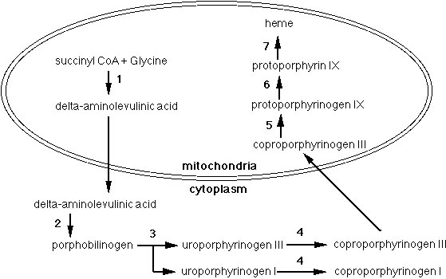

4. There are several different methods of enzyme regulation. The diagram below shows one such method.
a) What enzyme causes chymotrypsinogen to become active? ___________________________
b) Describe how the enzyme in question "a" does this. _______________________________________
___________________________________________________________________________________
c) What specifically links Chains A,B,and C of alpha-Chymotrypsin? ___________________________
d) How many amino acids does Chymotrypsinogen have? ________
e) How many amino acids does alpha-Chymotrypsin have? ________
f) Describe one other way that enzymes can be regulated (in general). __________________________
____________________________________________________________________________________
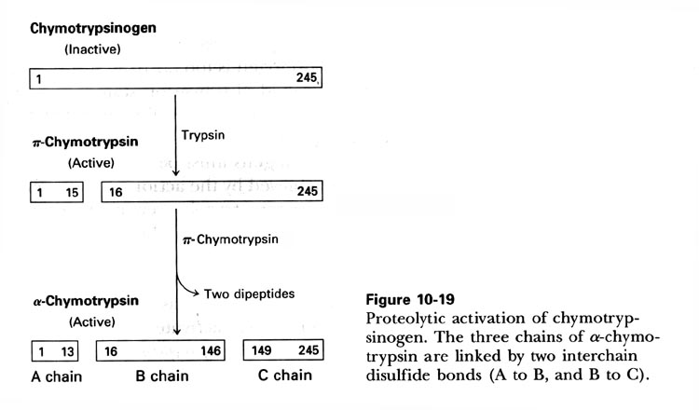

5. You are working for a professor in the Department of Biochemistry at UC Berkeley. You are investigating a newly discovered enzyme called MVBio-7. MVBio-7 is a protein that consists of 257 amino acids and is found in the cytoplasm of human cells. The substrate for this enzyme is citric acid. You begin your research by focusing on a small portion of the enzyme (amino acids #52 through #62 in the chain). The amino acid sequence of this region is: 52 VLIPMFVLFAV 62
Amino Acid Classification
Polar | Hydrophobic | Charged (Basic) | Charged (Acidic)
Glycine (G)  Serine(S)  Threonine (T)  Tyrosine (Y)  Cysteine (C)  Glutamine (Q)  Asparagine (N) | Alanine (A)  Valine (V)  Leucine (L)  Isoleucine (I)  Proline (P)  Tryptophan (W)  Phenylalanine (F)  Methionine (M) | Lysine (K)  Arginine (R)  Histidine (H) | Aspartic Acid (D)  Glutamic Acid (E)
a) The cytoplasm of cells is composed highly of water. Would you most likely find the 52-62 region in the inner portion of the protein or the outer portion of the protein? INNER or OUTER
b) Explain your answer to (a). __________________________________________________________
___________________________________________________________________________________
After careful experiments, you determine that the R groups of amino acids at positions 5, 7, 9, and 13 are very important in forming the active site of the MVBio-7 enzyme. They are vital in binding to the substrate (citric acid). Interestingly, glucose seems to inhibit the MVBio-7 enzyme. Glucose also seems to bind to the R groups of amino acids at position 5, 7, 9, and 13.
c) Describe two specific ways that a substrate may bind to the active site.
_____________________________________________________________________________
d) Would you describe glucose as a competitive or non-competitive inhibitor? ____________________
e) Explain your answer to (d). ___________________________________________________________
____________________________________________________________________________________
6. Recently, scientists have isolated a bacterial enzyme called phosphotriesterase that has the capability to break down toxins such as nerve gases (like sarin) and insecticides.
a) What kind of biomolecule is phosphotriesterase? (circle one)

LIPID CARBOHYDRATE PROTEIN NUCLEIC ACID

b) Suppose that when the nerve gas sarin is broken down into smaller, nontoxic molecules, the ΔG of the reaction is measured to be – 3.56 kcal. Draw the diagram
of this reaction on the graph to the right.
- Label the appropriate axes “Energy” and “Reaction Progress”.
- Label the products and reactants.
- Label the Activation Energy.

c) On the same graph, draw the reaction when phosphotriesterase catalyzes
the breakdown of sarin. Label this “With enzyme”.

d) Is the reaction that phosphotriesterase catalyzes (circle one)
ENDERGONIC or EXERGONIC

e) When phosphotriesterase is placed in a high pH or high temperature environment, it is no longer able to break down its substrates. Which of the following bonds may be broken to cause this result? (Circle all that apply)
peptide bond hydrogen bond ionic bond disulfide bonds

f) Given this potential for a bioterrorism antidote, the Department of Defense is interested in modifying phosphotriesterase so that it is able to catalyze the reaction even faster. To do this, they change a single amino acid that is part of the active site from a nonpolar amino acid to a positively charged amino acid. Use what you know about protein structure to explain how changing this amino acid could potentially improve (change) the enzyme’s ability to perform its function. __________________________________________________________________________________________
__________________________________________________________________________________________________

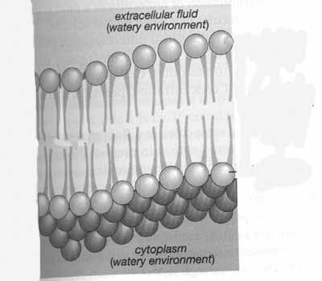
7. Scientists have isolated a type of bacteria that live at extremely cold temperatures such as those in the Arctic Circle. You are studying these organisms to determine what kinds of adaptations these organisms possess that make them well-suited to their environment.
a) Phospholipids, composed of phosphate groups and fatty acids, make up most of the cell membrane in all living organisms. A section of the cell membrane is shown on the right. Circle the part of the phospholipid bilayer diagram that contains the phosphate groups. Label it “phosphate”.

b) Which would you expect there to be more of in the phosholipids of these cold-loving bacteria? (circle one)
SATURATED FATTY ACIDS UNSATURATED FATTY ACIDS
c) Explain your answer to part (b) ____________________________________
________________________________________________________________
d) In order for molecules to enter or exit a cell, they have to get past the cell membrane. Because of its properties, the cell membrane is selectively permeable (only lets certain molecules through). Which of the two molecules (that are the same size) would be able to cross the cell membrane to get to the other side? (circle one)
NONPOLAR MOLECULE POLAR MOLECULE
e) Explain your answer to part (d) ____________________________________________________________________
________________________________________________________________________________________________

8. One characteristic shared by all cells is the presence of the plasma membrane. The plasma membrane is often described using the Fluid Mosaic Model.
a) Which of the following would you expect to cause the membrane to be more solid (less fluid). Check all that apply:
______ Presence of cholesterol at low temps ______ High Temperatures
______ Presence of saturated fatty acids ______ Low Temperatures
______ Presence of unsaturated fatty acids

b) Explain why the membrane is described as a mosaic. Be specific in your answer. _____________________________
__________________________________________________________________________________________________
__________________________________________________________________________________________
9. The two polynucleotide chains in a DNA molecule are attracted to each other by:
a. Covalent bonds between carbon atoms c. Hydrogen bonds between bases
b. Peptide bonds between amino acids d. Covalent bonds between phosphates and sugars

10. Phospholipids are classified as
a. nonpolar molecules c. polar molecules
b. both nonpolar and polar molecules d. neither nonpolar nor polar

11. An enzyme increases the rate of a reaction
a. by supplying the energy needed to speed up a reaction c. by decreasing entropy
b. by lowering the activation energy of a reaction d. by lowering the deltaG of a reaction

12. An enzyme that is brought to a lower temperature than its ideal temperature may:
a. Have more collisions with substrates
b. Begin to break hydrogen bonds between amino acids.
c. Become inflexible and may not allow the substrate to react in the active site.
d. Break covalent bonds between amino acids because it will freeze.
e. Lose its primary structure.

13. C. elegans is a widely used organism in biological research. It is a multicellular worm. As a graduate student, your first project is to look at the regulation of a gene called Wrm3. The Wrm3 protein is expressed during the early stages of development. The following DNA segment of the Wrm3 gene is below (including the upstream region):

3'- cctcaaatcactctCCAGTTAGAacgacccttagtcacagtaagaatagggggacagatCCtagaATATTAagccctat -
5'- GGAgtttagtgagaGGTCAATCTtgctgggaatcagtgtcattcttatccccctgtctaGGatctTATAATtcgggata -

- tagacacaggagCGTTGgaCacagtaCCgaaTaCGtaagtttaccaggaagatggaagccaatcatgatagggggaatt –5
- atctgtgtcctcGCAACctGtgtcatGGcttAtGCatTcaaatggtccttctaccttcggttagtactatcccccttaa –3

The -75 promoter region is 5'- GGNCAATCT -3' and the -25 promoter region is 5'- TATAAT -3'.
a) Make a box around any promoter regions that you see in the above DNA sequence.
b) Put an arrow to a region of DNA that is considered the CODING strand.
c) Circle the +1 nucleotide in the above DNA sequence.
d) What are the first five nucleotides of the mRNA that will be made? _______________________________
e) Using the genetic code provided, what are the first four amino acids translated? ______________________
f) What might occur if the underlined sequence is deleted? ________________________________________
_________________________________________________________________________________________
g) What might occur if the bold CG pair is changed to a TA pair? (be specific in your analysis) _____________
__________________________________________________________________________________________
h) How is transcription stopped? ______________________________________________________________
__________________________________________________________________________________________

14. Describe two ways in which a mutation in a gene will not result in any loss of function of the protein product of that gene.
a) ________________________________________________________________________________
b) ________________________________________________________________________________

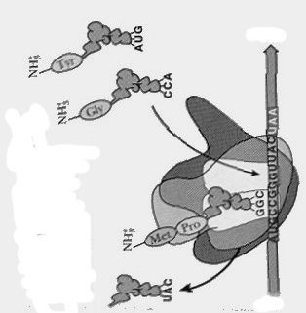
15. The diagram to the right shows one of the stages of Protein Synthesis.
a) Label the 5' and 3' ends of the mRNA.
b) Label the A site of the Ribosome.
c) Circle an anticodon.
d) Put a square around a codon.
e) What type of bond is between Met-Pro? _____________
f) What will happen to a tRNA that has left the ribosome after its amino acid has been added to the polypeptide chain?
_________________________________________________
_________________________________________________
_________________________________________________

16. Which of the following processes is RNA Polymerase involved in?
a) Translation b) Transcription c) RNA Processing d) Secretion
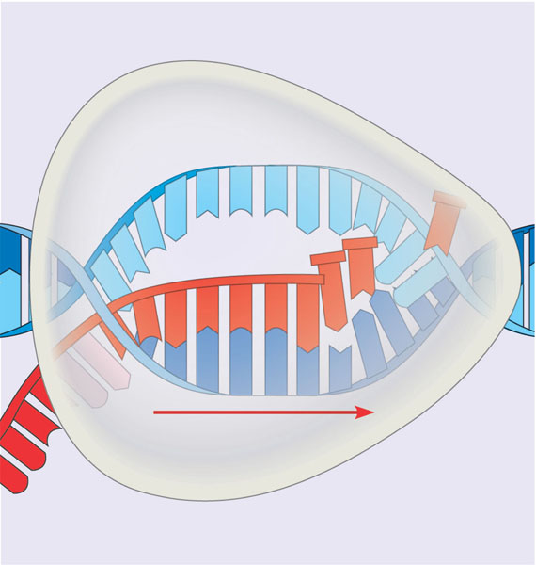
Strand A
Strand B
Direction of transcription
Strand C
17 Which of the following does RNA Polymerase recognize and bind to to begin working?
a) Start codon c) mRNA
b) Promoter d) 5’ cap

18. In the diagram to the right, Strand A is running in which direction (from left to right)?
a) 5’ to 3’ b) 3’ to 5’

19. In order for the process shown to the right to begin in a eukaryotic cell, which of the following would have to take place?
- transcription factors bind to the promoter
- repressor proteins bind to the operator
- a poly A tail is added
- introns are removed

20. If the nucleotide sequence in Strand A is AGCTCCA, what is the corresponding sequence on Strand C? ___________

21. For the figure below, determine which term belongs in each square. Each term is only used once. Some terms will not be used at all.
mRNA termination sequence tRNA Ribosome stop codon
amino acid release factor anticodon polypeptide start codon
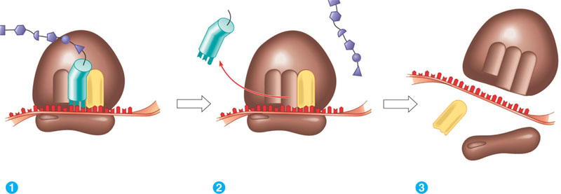
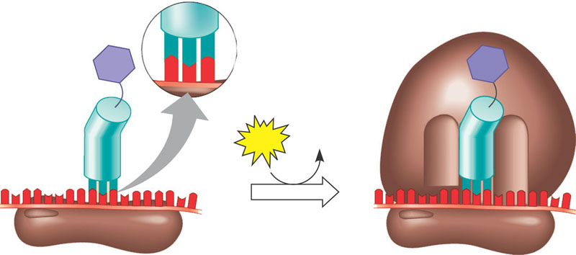

22. In addition to the main 2 steps of protein synthesis, there are additional processes that take place between these two steps. For the following description, fill in the blanks with the appropriate terms for these processes.

RNA Splicing results in the removal of ___________________ from pre-mRNA. The _________________ are kept and joined together, to create the final mRNA. A ___________________ and _____________________ are added to the two ends of the mRNA. This collective process of splicing and adding is called ________________________.

23. Glycoprotein X is a secretory protein that leaves the cell after it has been made. In a specific cell, glycoprotein X is made but it is not able to leave the cell. You suspect that this protein is unable to leave the cell because it has a mutation that destroyed the signal to direct it out of the cell.
a) What is missing from the mRNA sequence that codes for the mutated Glycoprotein X? (circle one)
Promoter Signal Sequence Start Codon Termination Sequence
b) In this cell, where would you expect to see glycoprotein X accumulate? (circle one)
Nucleus Cytoplasm Endoplasmic Reticulum Golgi Apparatus

24. You have begun your studies at Florida State University in the Microbiology Department. You are closely studing the genetics of Bacillus anthracis because of the recent concerns of the disease caused by this organism (anthrax). Specifically, you are looking at the genes that are responsible for producing proteins that are important in causing human infection. Hopefully, with more understanding of these proteins, more treatments against the disease could be developed.
The following B. anthracis DNA segment has been sequenced for you:

5-CTTGACACCGGATGCTTCCGGCTTCCCTATAATCGTATAGTGATTATGCCGTACCGTACG-3
3-GAACTGTGGCCTACGAAGGCCGAAGGGATATTAGCATATCACTAATACGGCATGGCATGC-5

The -35 promoter region is 5'-TTGACA-3' and the -10 promoter region is 5'-TATAAT-3'.
a) How does the RNA polymerase find the promoter region (at a molecular level)? _____________________
________________________________________________________________________________________
b) Make a box around any promoter regions that you see in the above DNA sequence.
c) Circle the +1 nucleotide in the above DNA sequence.
d) Draw an arrow to indicate what direction RNA Polymerase will transcribe in
d) What are the first five nucleotides of the mRNA that will be made? _______________________________
e) Using the genetic code provided (for now use the table in your notes), what are the first three amino acids translated? __________________________________

25. What types of RNA can be transcribed from DNA?
26. You map a region of E.coli's chromosome and make a sketch of it:

5'-------------------------------------------------------------------------------------------------------------------3'
3'----------------------------------------------------------------------+1------------ -10 -------------------------5'

a) Your professor asks you to finish the map by labeling the approximate places of: -35 promoter, DNA sequence for start codon, DNA sequence for stop codon, termination sequence
b) Next, label which strand is considered the template strand and which is the coding strand.

27. Micro-RNAs are small sequences of RNA in eukaryotic cells that scientists are very interested in learning more about. Based on current research, it appears that micro-RNAs may be involved in preventing certain genes from being expressed (carrying out protein synthesis).
a) Scientists believe that micro RNAs work by binding to strands of mRNA in order to prevent protein synthesis. Which specific process would micro-RNAs inhibit (prevent from taking place)? (circle one)
TRANSCRIPTION TRANSLATION
b) Why would a micro-RNA be effective at preventing protein synthesis? (check one)
______ It would prevent RNA Polymerase from binding. ______ It would change the poly A tail.
______ It would change the termination signal. ______ It would prevent tRNA anticodons from binding to mRNA codons.

c) In addition to the answer you picked in part (b), what else can microRNAs do to block protein synthesis?

